**DAILY ONLINE ACTIVITIES SUMMARY**

|  |  |  |  |  |  |  |  |  |
| --- | --- | --- | --- | --- | --- | --- | --- | --- |
| **Date:** | **2-06-2020** | | | | | **Name:** | **Javahar.S.Goutham** | |
| **Sem & Sec** | **7 B sec** | | | | | **USN:** | **4AL16CS132** | |
| **Online Test Summary** | | | | | | | | |
| **Subject** | | **No test** | | | | | | |
| **Max. Marks** | | **-** | | **Score** | | | **-** | |
| **Certification Course Summary** | | | | | | | | |
| **Course** | **Introduction to ethical hacking(completed)**  **Rpa (completed)** | | | | | | | |
| **Certificate Provider** | | | **Great learning**  **Guix** | | **Duration** | | | **6+3 =9hrs** |
| **Coding Challenges** | | | | | | | | |
| **Problem Statement**: 1.Python program to return a list containing first and last element using list slicing method.  **2.** Write a java program to check if given linked list has a loop or not.  **3.** Given an array of positive integers. Write a C Program to find inversion count of array. | | | | | | | | |
| **Status: YES, Completed all Programs.** | | | | | | | | |
| **Uploaded the report in Github** | | | | | **YES** | | | |
| **If yes Repository name** | | | | | <https://github.com/alvas-education-foundation/Dhanya-bhat-4AL17CS027> | | | |

Online Test Details: (Attach the snapshot and briefly write the report for the same)

No te

Certification Course Details: (Attach the snapshot and briefly write the report for the same)

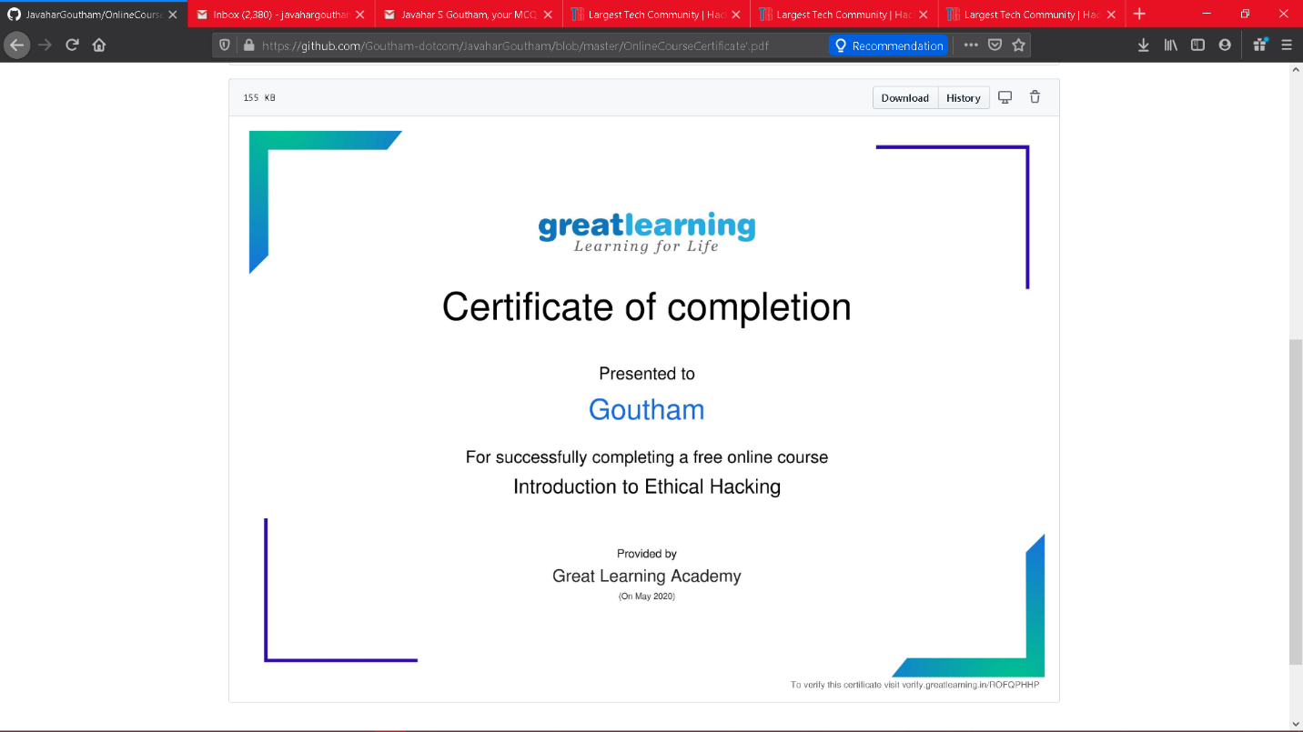

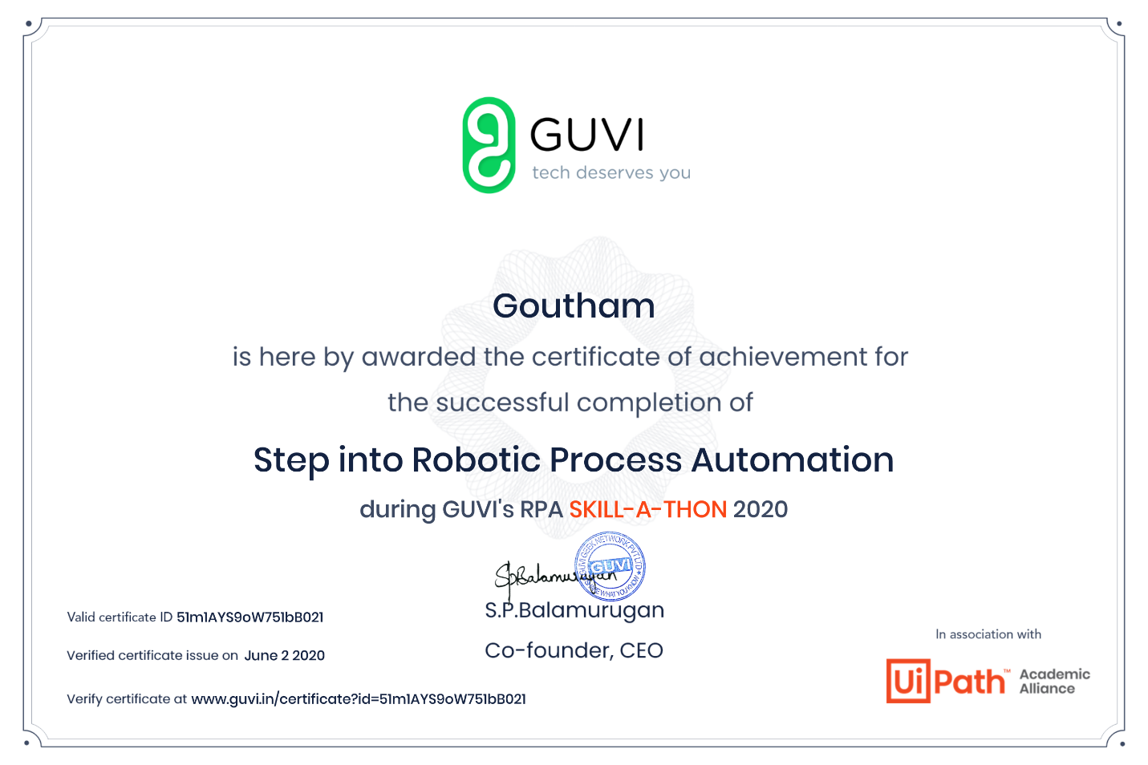

Successfully completed BecomeEthical hacking course and RPA

Coding Challenges Details: (Attach the snapshot and briefly write the report for the same)

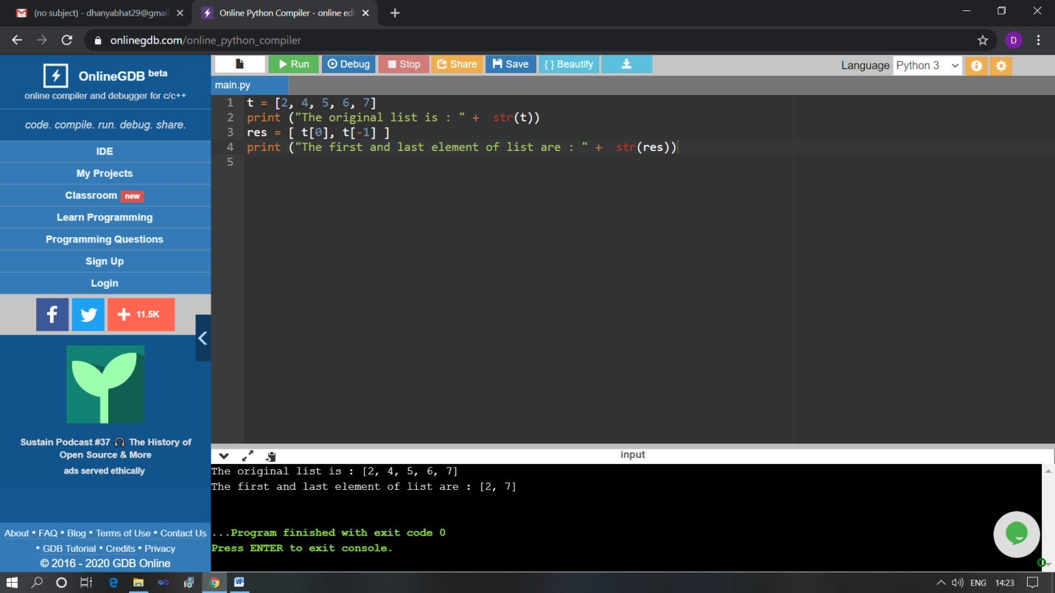

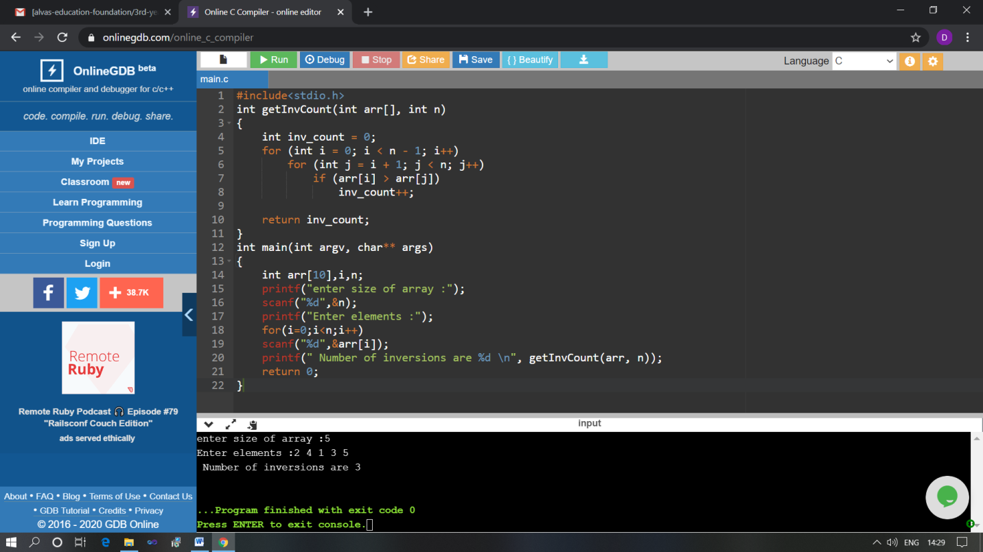

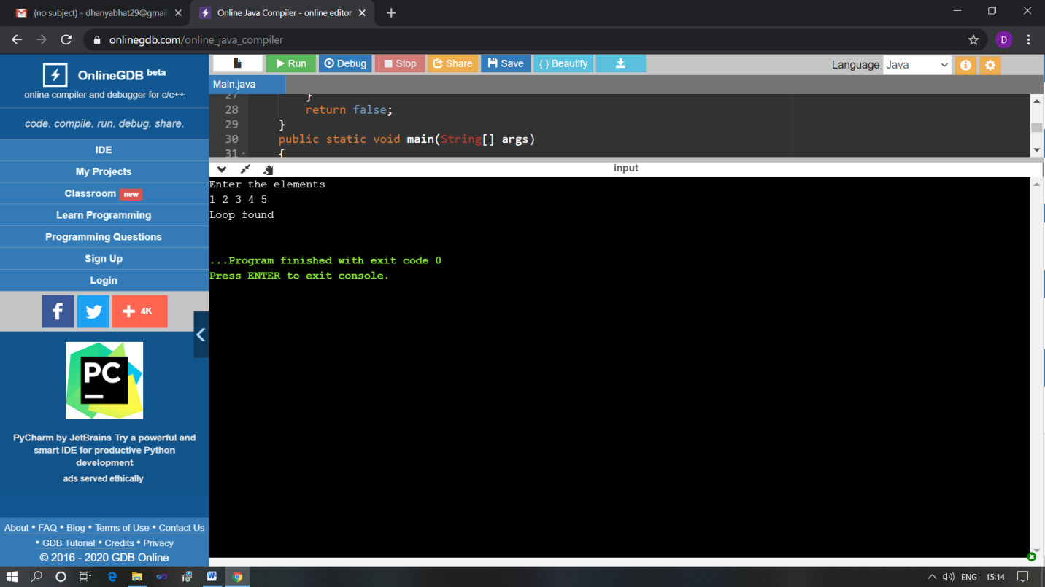

The above Programs were written and executed and the output of the same is displayed above. The code for those 3 programs have been uploaded to the github repository and the link to the same is provided on the form.